Web Design and Databases (F27WD)

COURSEWORK 2

Team Members-

Hasan Kapadia (Team Leader)

Farhan Alvi

Waleed Rashed

Part 1- Design the database / write sql to create the tables:

Relational Diagram-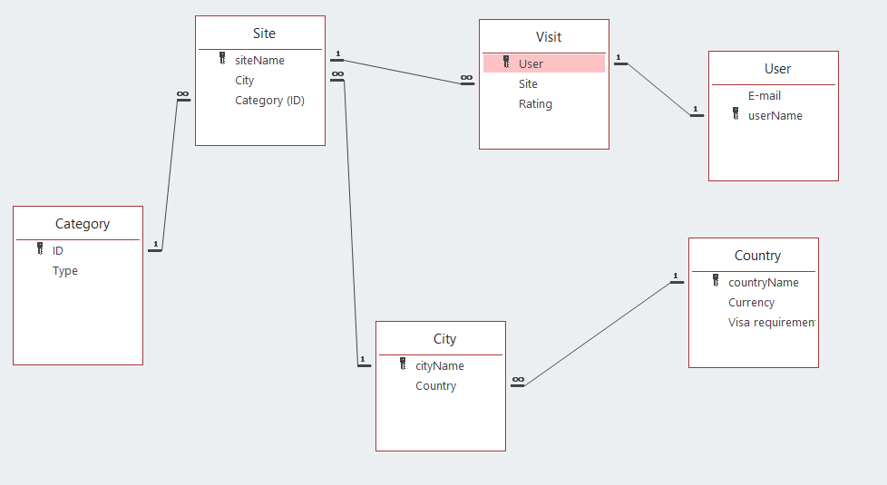

SQL Code (Create tables)-

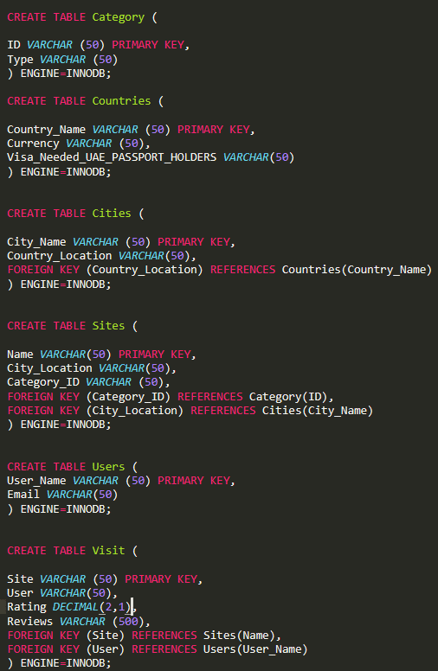

SQL CODE (INSERT TABLE VALUES)-

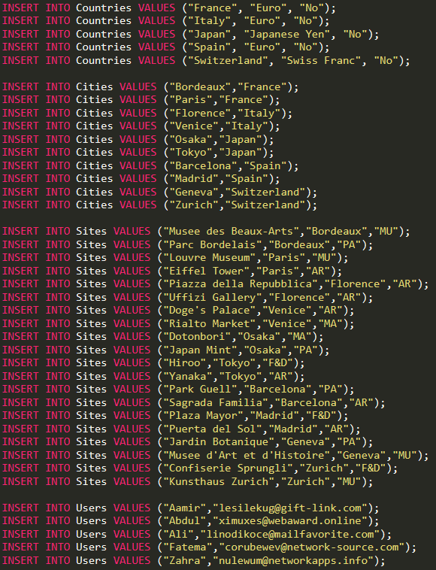

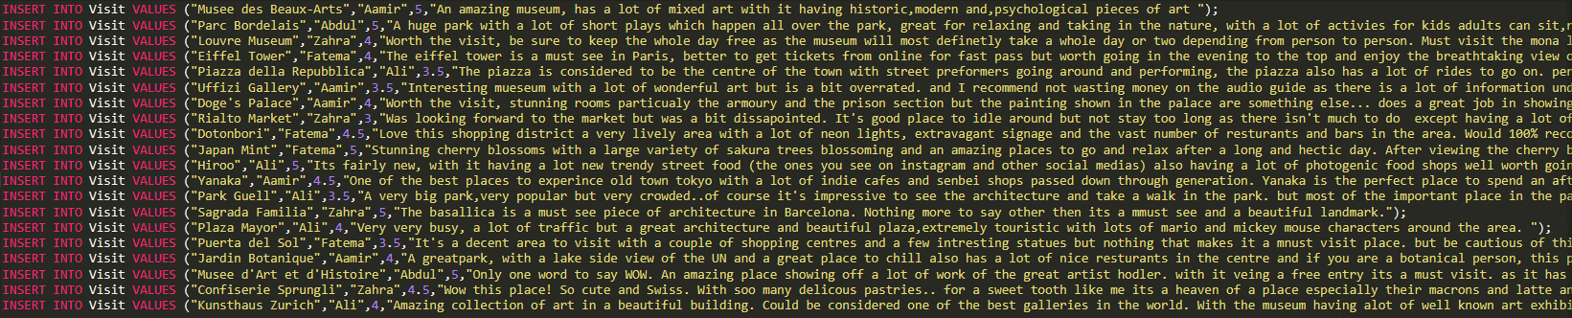

Part 2- Querying the database:

SQL Queries-

1. Return a list of all the cities that contain a museum.
2. Return a list of all the cities you can visit without a visa. Use a JOIN to connect the tables.
3. Rewrite the above query without using JOIN.
4. Choose a site of interest from your list and return a list of all the users who have visited it.
5. Displaying the names with an initial letter of "A" whose rating was greater than 4.
6. Displaying both the distinct emails and ratings of users whose ratings were greater than the average rating of all that user's ratings.
7. Return a list showing, Sites (With country and city the sites reside in and if Visa needed for UAE passport holders, Currency needed and category )) with a “Must see/visit” review and a rating of 4 and above.

SQL CODE (Queries)-

QUERY 1

select City_Name from Cities where City_Name in (select City_Location from Sites where Category_ID = "MU");

or

select City_Name from Cities INNER JOIN Sites ON Cities.City_Name = Sites.City_Location where Sites.Category_ID= "MU";

QUERY 2

select City_Name from Cities INNER JOIN Countries ON Cities.Country_Location = Countries.Country_Name where Countries.Visa_Needed_UAE_PASSPORT_HOLDERS = "No";

QUERY 3

select City_Name from Cities where Country_Location in (select Country_Name from Countries where Visa_Needed_UAE_PASSPORT_HOLDERS = "No");

QUERY 4

select User from Visit INNER JOIN Sites ON Sites.Name = Visit.Site where Sites.Name = "Eiffel Tower";

Extra Queries

5-

select Site, Rating from Visit where SUBSTRING(User, 1, 1) ="A" && Rating > 4;

6-

Sum of ratings = 83

Avg = 4.3

select distinct Email, Rating from Users INNER JOIN Visit ON Visit.User = Users.User_Name where Visit.Rating > (select AVG(Rating) from Visit);

7-

SELECT DISTINCT countries.country_name AS Countries, cities.City_Name As Cities, countries.currency AS Currency, countries.visa_needed_uae_passport_holders AS Visa_Needed_UAE_Passport_Holder, visit.user AS Users, visit.site as Sites, category.type as Category, visit.Rating AS Ratings, Visit.Reviews AS Reviews FROM Countries, Cities, Visit, Category WHERE countries.country_name = cities.country_location AND visit.Rating >= 4 AND visit.reviews LIKE '%must%' ORDER BY City_Name;

Part 3- Querying through PHP:

Sites.php-

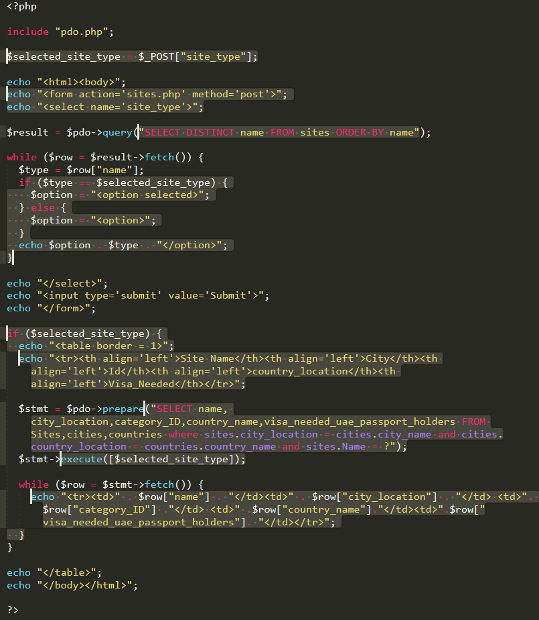

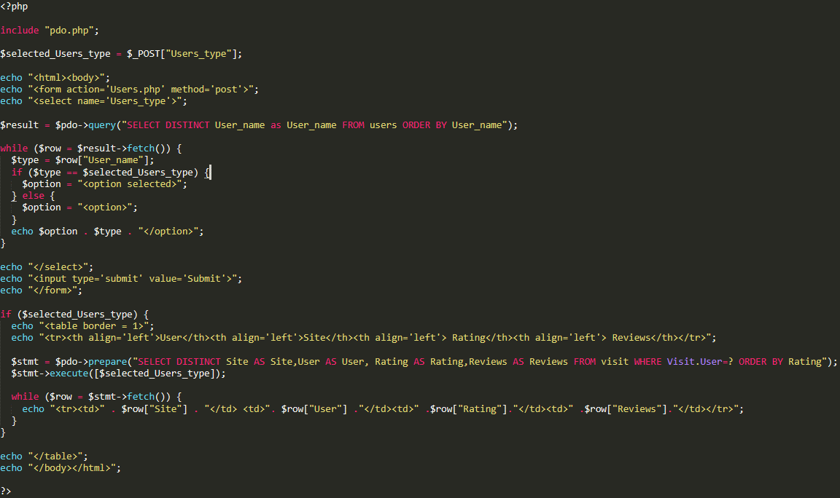Users.php-

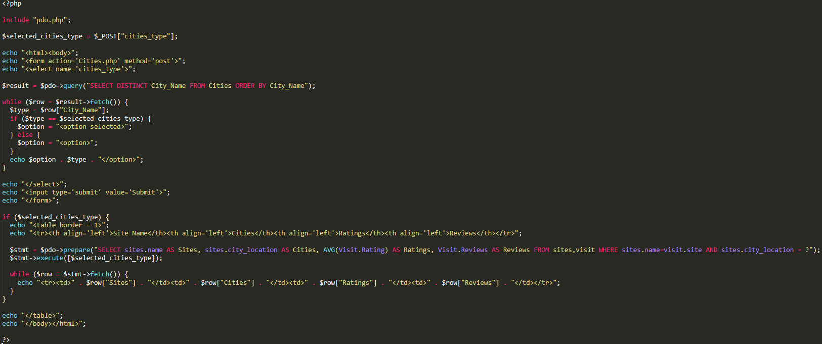Cities.php-

Effort Points (Given out of 5 per member)-

Part 1-

Part 1 (Relational Diagram & Writing SQL Code) was mainly assigned to Farhan Alvi but was also aided by Waleed Rashed and Hasan Kapadia but mainly done by Farhan Alvi.

Part 2-

Part 2 (SQL Queries) Assigned to Waleed Rashed. Aided by Hasan Kapadia & Farhan Alvi. Mainly focused by Waleed Rashed.

Extra Queries made in team meeting which we had on Sunday, March 23rd.

Part 3-

Part 3 (PHP) Done by Hasan Kapadia. Aided by Waleed Rashed and Farhan Alvi.

Farhan and Waleed both were given extra challenging task alongside their CW2 parts to aid their learning.

Effort Points given to team members-

Waleed Rashed- 5/5

Farhan Alvi- 5/5